Q1).
a). Plot the load line for the resistor on this characteristic and hence find the quiescent point.

When V_{d} = 0V I_{d} = 5/100 – 0 = 0.05 A (Max Id Value)

When V_{d} = 5V I_{d} = 5/100 – 5/100 = 0 A (Min Id Value)

What are the DC bias conditions of the diode? (ie V_{d} and I_{d})

At the quiescent point:-

V_{d} = 0.6 V
I_{d} = 0.043 A

b). Draw the AC equivalent circuit of the given circuit and hence find the AC voltage, V₀, under these conditions.

R₁ = 100Ω

V_{ac} = 10mV

R₂ = 0.6Ω V₀ = 5.96 * 10⁻⁵ V

The D.C. current running through the diode, shown on the graph at the quiescent point: -

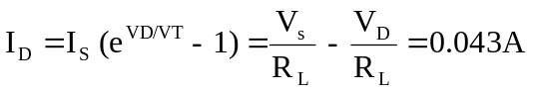Diode resistance at the operating conditions: -
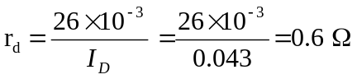

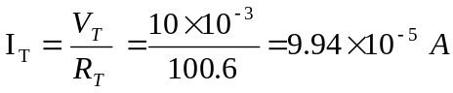Voltage drop across the resistor in relation to the A.C. voltage source: -

V₀ = I_{T} * R_{d} = 9.94 * 10⁻⁵ * 0.6 = 5.96 * 10⁻⁵ V

c). The DC voltage from the generator is now lowered to 2.5V. What will the AC voltage be now?

The D.C. bias conditions for this circuit is slightly different than in the previous circuit. If we now plot the load line for this new configuration onto the diode characteristic graph, at the quiescent point we have: -

V_{d} = 0.06V
I_{d} = 0.018A

The circuit is now changed into it’s A.C. equivalent, because the D.C. voltage is altered in the new practical circuit, the value of r_{d} will be different.

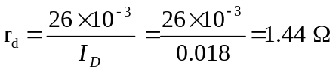
Voltage drop across the resistor in relation to the A.C. voltage source: -

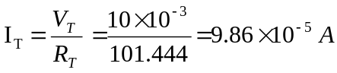
V₀ = I_{T} * R_{d} = 9.86 * 10⁻⁵ * 1.44 = 1.42 * 10⁻⁴ V

